

**Dunstable Town Council**

Priory House, Dunstable

Project Execution Plan





July 2024

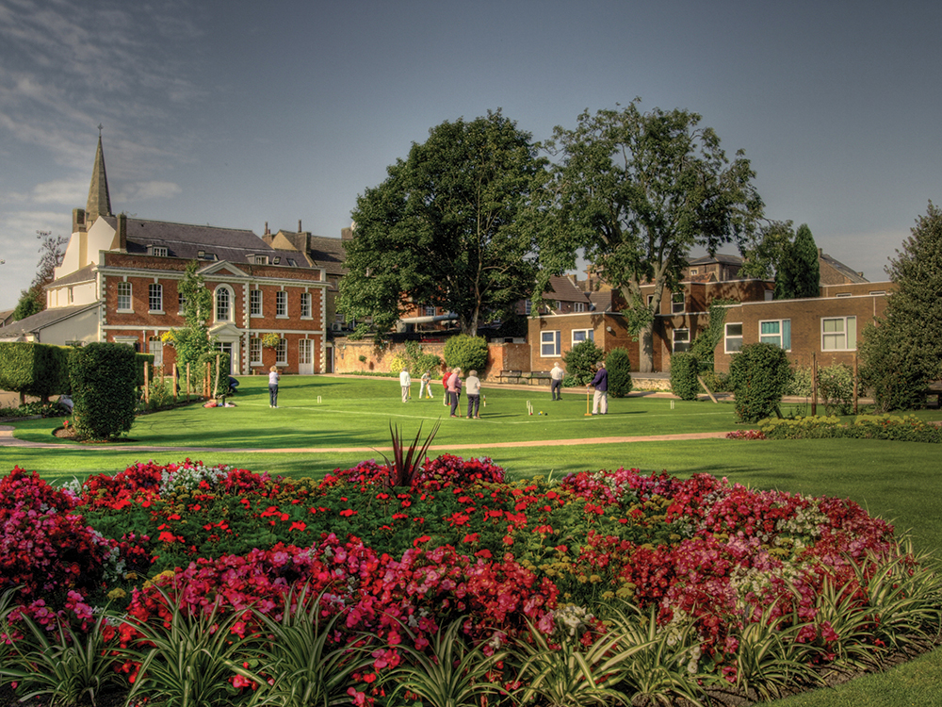

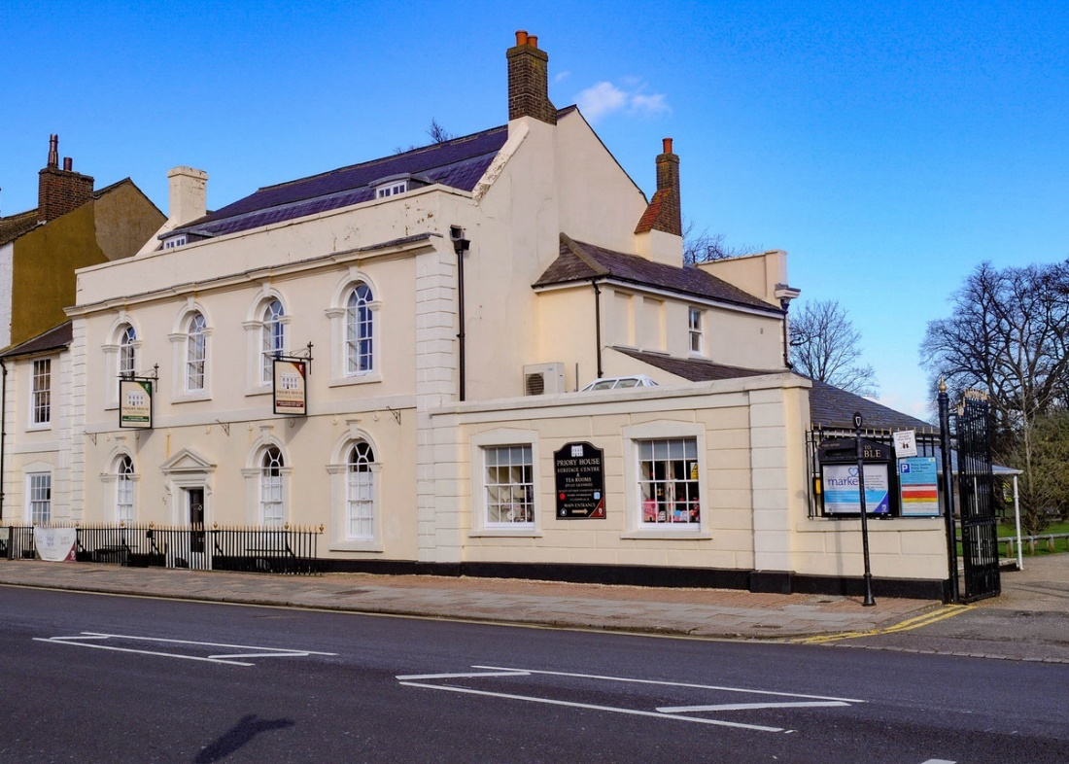

Contact Information

|  |  |
| --- | --- |
| Client: | Dunstable Town Council  Heritage Action Zone (HAZ)  Grove House  76 High Street North  Dunstable  LU6 1NF |
| Client Lead: | Becky Wisbey |
| Email: | [Becky.Wisbey@dunstable.gov.uk](mailto:Becky.Wisbey@dunstable.gov.uk) |

Contents Page

|  |  |  |
| --- | --- | --- |
|  |  | Page |
| 1.0 | Introduction | 4 |
| 2.0 | Project Parameters | 5 |
| 3.0 | Project Organisation | 12 |
| 4.0 | Project Controls | 16 |
| 5.0 | Health and Safety | 21 |
| 6.0 | Statutory and Legislation | 22 |
| 7.0 | Interdependencies and Risks | 24 |

Appendices

Appendix A - Scoping Prioritisation

Appendix B - Programme Gantt Chart

Appendix C - Risk Register

Appendix D - Consents Tracker

**1.0 Introduction**

* 1. **Project Status**
     1. ‘Priory House, Dunstable’ is a project to complete the restoration of the Grade II* listed Priory House in Dunstable and remove it from the Heritage At Risk Register.
     2. It is currently in Construction stage on site, albeit with some discovery items progressing through design development, the majority of details have been issued For Construction.
     3. The project is awaiting the outcome of grant funding applications, with decisions expected by September. The Design Team are working closely with the contractor to ensure that all construction details have been agreed by the time the funding decisions have been made and the works can recommence in earnest.
  2. **Purpose of Document**
     1. This Project Execution Plan (PEP) sets out the project governance structure for the completion of the ‘Priory House, Dunstable’ project.
     2. This document sets out the delivery process following the RIBA Plan of Work 2020. The project is part way through RIBA Stage 5 – Construction, with the majority of works currently paused pending outcome of funding decisions.

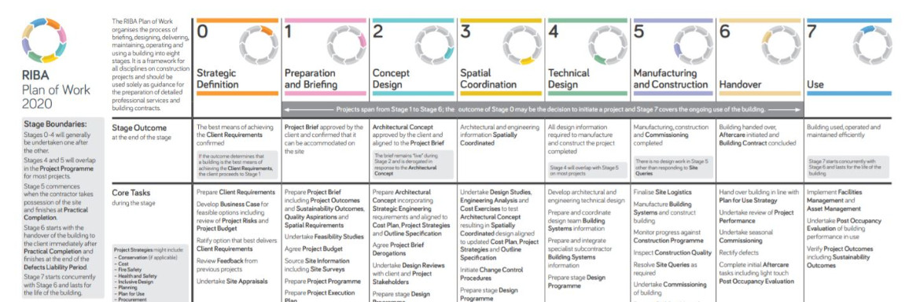

1. **Project Parameters**

**2.1 Authority**

2.1.1 The Client for the project is Dunstable Town Council (DTC)

2.1.2 Funding support is being provided by:

* High Street Heritage Action Zone (HSHAZ)
* Historic England Heritage At Risk (HE/HAR)
* National Lottery Heritage Fund (NLHF)

* 1. **Objectives**

2.2.1 The objectives of the Priory House project at the outset were:

* Repair and conserve the vaulted stonework of the undercroft.
* Develop a better understanding of the environmental conditions alongside the building structure, fabric and the nature of clunch, to allow the current uses to continue but to control the building environment to significantly reduce the rate of deterioration.
* Provide detailed guidance to Dunstable Town Council on how to manage the building’s environment and maintain the fabric, as custodians for its future.
* Remove the building from the Heritage at Risk Register.
* Project evaluation.
* Take proactive measures to be inclusive, remove barriers to access and reach new and diverse audiences through the delivery of this project.

2.2.2 Following the opening up of the building further issues came to light that expanded the objectives:

* + Address identified issues with:
    - Deterioration of the East (Spine) Wall and associated walls.
    - Substantial structural repair of the walls including significant localised alterations.
    - Removing redundant electrical installations and replacing active electrical installations to bring up to standard.
    - Repair of the north gable to allow the second floor attic space to be safely brought back into use.
* Provision of flood alleviation measures and flood resilient design, following further flooding of the High St and building in June 2023
* Historic Building Recording and wall paintings expert assessment.
* Upgrade the building’s fire resilience to bring it up to latest standards.
* Reinstate all spaces to enable the building to reopen for full public use.
  1. **Project Scope**

1. * 1. The scope of works expanded significantly following the opening up, the intrusion into spaces that were originally going to remain untouched, the necessary removal of the interpretation panels that were too heavy for the structure of the building, and the completion of a full condition survey of the building.
     2. The expanded scope was costed and a prioritisation exercise undertaken as detailed at Appendix A.
     3. The refined scope is now set at the following, subject to securing the necessary funding.

|  |  |
| --- | --- |
| **Description** | **Cost £** |
| Original Contract Scope incl Professional Fees | 2,572,362 |
| Completing remaining works from original contract to the undercroft including scaffolding and temporary supports | 59,519 |
| Flood resilience work | 216,731 |
| Internal East (spine) wall repairs and associated structures | 86,255 |
| Items arising from condition survey: |  |
| Repairs to main roof east side (including scaffolding) | 18,000 |
| North side annex roofs (including scaffolding) | 24,460 |
| Loft roof repairs | 7,615 |
| North gable | 46,648 |
| Internal reinstatement: |  |
| Second floor - new floor decking and finishes, including insulation and acoustic strips, making good wall and ceiling plaster, and redecorating | 30,990 |
| First floor Exhibition space - reinstating floors, making good wall and ceiling plaster | 106,713 |
| First floor Exhibition space - conservation and stabilisation of historic paint traces and wall paintings | 53,692 |
| First floor Jacobean room - repair lath and plaster and making good finishes generally (conservation works below) | 32,066 |
| First floor auxiliary spaces - modern spaces affected by internal east (spine) wall repairs, minor making good of lathe and plaster, removing and replacing modern floor finishes, and decoration | 14,006 |
| Undercroft - additional work to the contract work; additional plastering (reinstating plaster that had to be removed as part of the investigations), new floor boarding, and repairs to marble floor | 28,248 |
| Tea rooms - reinstating finishes, decorating, spaces disturbed by the works | 48,833 |
| Stairwell - making good finishes, reinstating dado and architraves, decorating | 62,253 |
| Recommission lift | 2,052 |
| Fire protection measures to meet Building Regs and Fire Safety Act requirements | 139,141 |
| Miscellaneous variations to original contract works (masonry work in undercroft, render repairs, joinery work) | 16,546 |
| Preliminaries to completion of works | 446,793 |
| Risk allowances for remaining works - based on costed risk assessment | 233,359 |
| Inflation allowance on remaining works - subject to final negotiation with Trades | 84,747 |
| Professional Fees Associated with the above | 631,018 |
| **TOTAL** | **4,962,049** |

**2.4** **Project Process**

| **Project Process** | | |
| --- | --- | --- |
| **Stage** | **Deliverables** | **Approvals** |
| **RIBA Workstages 2-4** | For the new items identified through the opening up and condition survey:   * Design team to develop initial proposals for discussion and agreement of principles with HE and CBC * Detailed and technical designs to then be developed in conjunction with the conservation contractor before submitting details to HE and CBC for approval * Development of details to be prioritised in order to suit contractor’s construction programme * Planning Performance Agreement in place with CBC and regular check-ins with HE to expedite approvals process * Schedule of details and timing of submissions to be developed to agree dates for information receipt, consideration, and decision * Approved Inspector appointed to review and approve Building Control related matters | Dunstable Town Council Project Lead  Historic England (HE)  Central Bedfordshire Council (CBC) Planning Authority  Building Control |
| **RIBA Workstage 5**  Manufacturing and Construction | * Contract Administration in accordance with the contract * Monthly progress meetings * Fortnightly dashboard reports prepared by the Project Manager Monthly noting progress, decisions/info required/consents status * Monitor progress against construction programme and ensure timeliness of information issue to suit programme * Inspect construction quality and resolve site queries as required * Undertake testing, witnessing and commissioning of building * Applications related to formal discharge of conditions of pre-agreements in relation to the Listed Building Consent * Comply with Statutory Conditions related to Construction * Snagging * Prepare Building Manual including maintenance plan in line with HE requirements * Prepare operational plans * Develop interpretation and exhibition strategy (subject to separate funding) * Ongoing fundraising for interpretation and exhibition reinstatement | Dunstable Town Council Project Lead  Historic England (HE)  Building Control |
| **RIBA Workstage 6**  Handover | * + Building Control sign off   + Fire and Security sign off   + Update building Fire Risk Assessment   + Undertake seasonal commissioning   + Rectify defects   + Complete Final Account   + Comply with pre-occupation Planning Conditions if required   + Undertake evaluation | Dunstable Town Council Project Lead  Historic England  Building Control |
| **RIBA Workstage 7**  Use | * Occupation of facility * Continuation of environmental monitoring for one year post-occupation, followed by evaluation of data and adjustment of heating controls if required * Ongoing delivery of activity projects * Deliver interpretation and exhibition reinstatement (subject to separate funding) * Implement Facilities Management and Maintenance Plan * Undertake end of defects liability period inspection and complete items identified * Updated Building Manual including Health and Safety File and Fire Safety Information as necessary * Issue Final Certificate * Undertake evaluation | Dunstable Town Council Project Lead |

* 1. **Programme** 
     1. Key indicative milestones are set out here, with the funding decisions being critical to enable the rest of the programme that follows, along with timely statutory approvals to the additional works.
     2. The construction Gantt chart is included at Appendix B and the Consents tracker has dates each consent is needed by in order to meet this programme. A master programme is being developed and is to be managed by the Project Manager going forward.

| **Task** | **Estimated Completion Date** | **Comments** |
| --- | --- | --- |
| Additional funding decisions | 06/09/2024 | Committee dates to be confirmed with HE and NLHF |
| East wall repairs | 20/09/2024 |  |
| Determination of pre-agreements and consents | 30/09/2024 | Risk associated with capacity of Local Authority to approve |
| Ground floor reinstatement (Cafe and seating areas) | 01/11/2024 |  |
| Wall paintings consolidation | 18/11/2024 |  |
| North wall repairs | 20/01/2025 |  |
| Steelwork design and fabrication | 15/11/2024 |  |
| Second floor structural work | 30/12/2024 |  |
| Second floor carpentry and M&E first fix | 31/03/2025 |  |
| First floor structural work | 04/04/2025 |  |
| First floor carpentry and M&E first fix | 30/04/2025 |  |
| Second floor finishes reinstatement | 30/05/2025 |  |
| Undercroft stone conservation repairs | 05/08/2025 |  |
| Undercroft lime plaster and stone flooring | 05/12/2025 |  |
| First floor finishes reinstatement | 19/01/2026 |  |
| Strike scaffold | 26/01/2026 | Dependent on completion of upper floors work for access |
| External flood alleviation works | 09/03/2026 |  |
| External works | 28/05/2026 |  |
| Practical Completion | 09/06/2026 |  |

* 1. **Project Budget**
     1. The QS has developed the costs for the revised scope of works with the input from the Design Team and the Contractor.
     2. Construction cost at £3,284,342 ex VAT.
     3. Contingency allowances of £342,069 ex VAT.
     4. Inflation allowances of £108,263 ex VAT.
     5. Professional fees of £1,227,375 ex VAT
     6. Giving **total Project Budget of £4,962,049** ex VAT.
  2. **Tolerances and Contingency** 
     1. Risk allowances have been assessed for each element of the works to reflect the different levels of risk in each case. For example, a 10% allowance has been included for residual contract works where the scope and nature of work is well defined; whereas 20% has been allowed in the fire protection measures as this remains subject to ongoing design and uncertainties with regard to the exact routing of pipework for the misting system and application of design principles in specific locations (e.g. specific doors).
     2. It should be noted that the team have identified significant structural concerns with the North Gable which will require repair and conservation of painted timber studs. Given the nature of this work that will not be fully ascertained until the works commence, these costs have a greater element of risk attached to them compared to works that have been able to be worked through in greater detail already.
     3. **Contingency**

The project team have worked hard to get designs to RIBA 4, and in doing so reduces the risk of costs being significantly out.

Contingency has also been weighted where we have been unable to get this level of detail in time for the grant uplift submissions and for these elements there will be a higher level of contingency to address the increased level of risk.

There have also been additional time allocations factored in and preliminaries costs associated with this.

The costs have been prepared by the QS with input from the contractor and their trades. Sequencing of the works has been considered and allowed for within the programming exercise, along with availability of materials and specifications aligned to suit this.

Whilst we cannot identify every “unknown unknown”, we have cast the net as wide as possible in the scoping exercise to put figures against all potential items arising, and then refine this back down to the essential works and interdependent works, to avoid any later scope creep or forgotten costs.

* + 1. **Programme**

The team has interrogated the timescales to see where workstreams might be run in parallel or be accelerated. However, a deep dive of the programme revealed that there are limited opportunities to bring it forward.

1. The structural work has to be completed in sequence. Strengthening and repair to the internal east wall will enable the upper floor and roof loads to be transferred on to this wall, before works to the second and first floor can be completed. Only once these works are completed will the load be sufficiently redistributed to enable the works to the vaults to commence.
2. There is limited space within the building in which to work.
3. Even if more labour could work on the site, there is restricted space for welfare facilities, limiting the site labour to a maximum of 6-8 people under CDM Regs with current provision, including staggering breaks and working areas, potentially increasing to c. 10-12 people by using the facilities within the building.
4. The activities are reliant on a number of subcontracted trades. The Main Contractor is seeking to complete the stone work, flood alleviation, and some of the carpentry work with internal labour. Other key packages including blacksmith, M&E, limecrete, groundworks, and scaffold, are all dependent on the availability of specialists, of which there is a limited number available. Time periods built into the programme for the works factors in an element of lead-in time and float for availability.
5. We do not yet have full consents for all the works. We are working to put in place a Planning Performance Agreement with the Planning Authority to ease the consent process. The programme is predicated on the consents being in place to enable a full run at the works as soon as the funding is confirmed.
6. An Approved Inspector has been appointed to provide Building Control approvals to ease pressure on the Local Authority and mitigate this risk.
7. Access for materials into the upper levels of the building is through the first floor window via scaffold access. Bringing materials up the internal staircase risks damage to the historic fabric and also further restricts internal access. However, until internal works are sufficiently progressed to remove the scaffold, works to the externals, including the flood alleviation measures, such as the raising of plinth and the reinstatement of railings, cannot be undertaken.
8. The use of brick in conjunction with stone to undertake repairs has de-risked some of the supply chain issues, and the contractor has worked with the stone supplier to recover, sort and prepare the remaining material from the quarry following its closure.

Overall, the team have sought to put forward a realistic programme that all will seek to improve upon should trades become available sooner, and assuming consents can be granted in timely fashion.

A 15% risk allowance has been included for programme risk (preliminaries costs and fees).

* + 1. **Inflation**

Given the extended length of the programme, allowances for varying degrees of inflation have been factored in against the different packages to reflect the sequencing of the works. There are several considerations that have been accounted for:

* the extended period of working will result in some activities being undertaken beyond the original programmed date. An inflationary adjustment is included for these activities based on the Costmodelling.com building cost index.
* Although the additional works have been priced by the contractor, pricing was undertaken as the revised programme was being developed. There is a risk, therefore, that some activities will be subject to inflationary costs before they are caried out – some perhaps as much as 18 months after pricing. Inflation risk allowances have been included for these activities.
* Most of the works are being undertaken by specialist sub-contractors who tend to have a greater level of pricing power compared to the overall construction market. For example, the repairs to the railings will be undertaken by a specialist blacksmith and such specialists have the ability to pick and choose their work and dictate pricing. There is a risk, therefore, that inflationary adjustments based on a general building cost index will not cover such market vagaries and so an additional extra-over inflationary risk allowance is included.

1. **Project Organisation**

**3.1 Overall Project Organisation**

* + 1. This section is concerned with the governance and stakeholders for the development and delivery of the Priory House project to open doors. It does not seek to address the long-term governance of the resulting building and/or organisation. This will be set out in the Business Case.
    2. To date The Morton Partnership have supported the client, providing project management services. Given the expanding scope of works, it has been decided to introduce a specific Project Manager to provide support to the whole team and provide additional strength to the monitoring and reporting processes. This is reflected in the revised organogram overleaf.
    3. In addition, an Approved Inspector and Fire Engineer have been appointed to support on the Building Control related items.

**3.2 Project Structure**

**Project Organisation Chart - Priory House**

**Client**

Dunstable Town Council

**Project Funders**

Historic England, High St

Heritage Action Zone

Historic England, Heritage at Risk

National lottery Heritage Fund

**Contract Administrator**

The Morton Partnership

**Project Manager**

TBC

**Conservation Officer and County Archaeology**

Central Bedfordshire Council

**Quantity Surveyor**

Walker Associates

**Principal Contractor**

Messenger BCR

**Advisor to Principal Designer**

Philip Waller Consulting

**Principal Designer**

The Morton Partnership

**Lead Consultant and Conservation Structural Engineers**

The Morton Partnership

**Fire Consultant**

Salus

**Environmental Consultant**

Tobit Curteis Associates

**Masonry Subcontractor**

Cliveden Conservation

**Other Sub-Contractors**

Scaffolding, M&E

**Conservation Architect**

Caroe Architecture

**Wall Paintings Consultant**

Dr Andrea Kirkham

**M&E Engineer**

Martin Thomas Associates

**Approved Inspector**

Clark Banks (Building Control) Limited

**Buildings Archaeologist**

HB Archaeology & Conservation

* 1. **Terms of Reference**

| **Role** | **Responsibility** | **Meeting Structure** | **Individual/Organisation** |
| --- | --- | --- | --- |
| **Strategic Funders** | * Providing funding * Providing support and advice | * HE – monthly * NLHF – quarterly | High Street Heritage Action Zone  Historic England  National Lottery Heritage Fund | |
| **Project Director** | * Owns the Project vision * Keeper of project objectives * Decision maker within agreed authority limits * Escalates decisions where necessary * Budget holder * Key conduit to stakeholders | * Invited to specific workshops/key meetings * Strategic briefing at decision points * External facing/stakeholder management | Paul Hodson | |
| **Client Lead** | * Allocates resource on day to day basis * Main liaison point for the Project Team * Supports the Project Director and feeds in information as required * Liaises with wider client team to ensure coordination and feedback at key stages * Gathering client-side information and feedback * Route to engaging wider client team where necessary * Escalates decisions where necessary | * Catch ups with Project Director * Weekly one to ones with the Project Manager * Attends all project meetings * Invited to specific workshops when required | Becky Wisbey | |
| **Project Manager** | * Responsible for the delivery of the Project * Keeper of Quality, Programme, Budget, Risk in conjunction with the rest of the project team * Day to day management of professional team and contractors * Makes recommendation to escalate decisions where necessary * Supports on obtaining statutory permissions | * Weekly one to ones with the Project Director * Attends all workshops and project meetings * Attends strategic meetings as necessary, e.g. with Funders and Statutory Bodies | External appointment TBC | |
| **Lead Designer & Contract Administrator** | * Keeper of Project Design Principles * Keeper of Quality objectives and sign off works on site * Sets design strategies for consistency across sustainability, access, operations/maintenance * Leads on obtaining statutory permissions * Contract administration | * Leads the design process * Attends key workshops/ meetings * Ad hoc catch ups with Project Manager and Project Director to shape the project * Attends strategic meetings as necessary, e.g. with Funders and Statutory Bodies * Chairs Contractor Progress Meetings | The Morton Partnership | |
| **Principal Designer** | * Responsible for the Client’s discharge of duties under the CDM Regulations 2015 * Posting and updating the F10 * Review of contractor’s Construction Phase Plan * Oversee compilation of the Building Manual | * Attends key workshops/ meetings | The Morton Partnership advised by Philip Waller Consulting | |
| **Quantity Surveyor** | * Keeper of Project Financial Reporting * Manages budgets across projects and at strategic level * Ensures no gaps nor duplication * Considers efficiencies | * Attends key workshops/ meetings * Ad hoc catch ups with Project Manager and Project Director to shape the project * Liaison with the design team * Liaison with the contractor | Walker Associates | |
| **Design Team** | * Developing and delivering design proposals * Coordinating with each other * Identifying and commissioning surveys required * Providing For Construction information * Supports Lead Designer to provide information for Statutory Consents and discharge of conditions * Supports Lead Designer in signing off quality of works on site | * Design meetings as required * Attend specific workshops/ project meetings as required/where directed by Lead Designer * May be appointed individually or mix of individual appointments and multi-discipline appointments | Conservation Architect – Caroe Architects  Martin Thomas Associates – M&E Engineer | |
| **Specialists** | * Other appointments required to support the development and delivery of the individual project | * As required | Approved Inspector – Clark Banks  Fire Engineer – Salus  Environmental Conditions – Tobit Curteis  Wall Paintings Conservator – Dr Andrea Kirkham  Archaeology – HB Archaeology and Conservation | |
| **Contractor** | * Undertake the construction works | * Monthly progress meetings * Weekly site visits | Messenger + subcontractors | |

**4.0 Project Controls**

**4.1 Reporting Mechanism**

The cycle of reporting will be developed further in the next stage, once the team has been appointed. We include overleaf an indicative cycle for consideration.

**Site visits**

Weekly/Fortnightly

Led By: Lead Designer and PM

**Site Report**

Monthly

by Contractor

Work undertaken

Instructions Received

Information/ Decisions Required

Risks/Issues

**Half Hour Check Ins on Teams**

Fortnightly

Led By: PM

Notes: PM

Status of progress

Statutory approvals

Risk

**Dashboard Report**

Fortnightly

by PM

Progress

Key Decisions

Info required

Consents status

**Contractor Progress**

**Meetings**

Monthly

Led By: Lead Designer

Minutes: PM

**Funder Meetings**

Monthly or frequency to be agreed

Led By: Client Lead

Minutes: PM

**Progress Reports to Funders**

By Project Manager

With input from Client Lead and Project Team

**Decision Making Hierarchy**

* Set Fundamental Project Parameters (e.g. policy or budgetary): Dunstable Town Council, Historic England, National Lottery Heritage Fund
* Changes to Project Parameters (cost, programme, quality): Project Director
* Key Decisions within Approved Project Parameters: Client Lead and Project Director
* Recommendations for Key Decisions: Lead Designer and Project Manager
* Day to Day Instructions: Client Lead and Lead Designer/Contract Administrator
* Consultation/Input: Funders, Statutory Bodies

**Project Status Report**

`By PM with QS and Design Team

Progress

Programme

Cost & Change Control

Risk

**Steering Group**

**Meetings**

Monthly

Led By: PM

Minutes: PM

**4.2 Change Management**

4.2.1 Implementation of a change management process will help alleviate the impact of any problems that may arise as it ensures any changes that are required are fully thought through and the wider implications understood before the change is instructed. Below outlines the process for assessing changes.

Change/ Variation Issue arises

Raise Change Control Form

Risk assessment cost/ time/ design/ funding/ business case/ statutory/ interface implications and alternatives by Project Team/ Contractors

Confirmation - No significant cost/ time/ design implications

Quantity Surveyor Consideration/ Report

Client/ Project Manager Discussion/ Instruction

Alternative solution

sought

Change/Variation implemented or rejected and logged

***PM logs***

***Contract Administrator instructs Contractor***

**4.3 Risk Management**

4.3.1 The project team will be collectively charged with identifying and managing risk throughout the project so that it is avoided or minimised.

4.3.2 The current risk register is contained at Appendix C.

4.3.3 The risk register will be reviewed at the monthly Progress Meetings and the top risks reviewed at the fortnightly check ins.

**4.4 Value Management**

4.4.1 The design should be measured against the key drivers for the project at each stage and refined accordingly to ensure strong value management.

4.4.2 The project has undergone a detailed value assessment and scope prioritisation exercise following the principles set out overleaf. Out of this the Essential and High Priority elements have been identified for delivery. This process will be revisited throughout the delivery of the project should it become necessary to offset any further increase to the costs that cannot be contained within the contingency and inflation allowances.

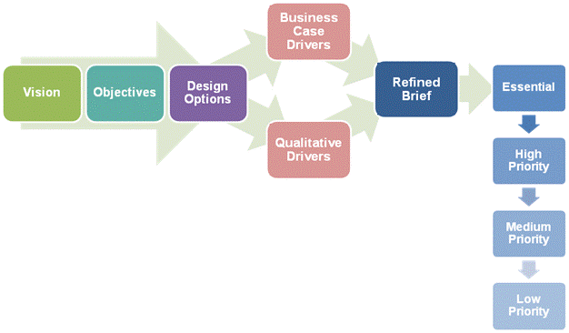

**4.5 Quality Management**

**4.5.1 Quality Objectives**

The Quality Objective is to deliver the Project to meet the objectives set out in this document.

**4.5.2 Project Management and Quality**

The Project Manager will maintain an overview of the project in terms of assuring the quality of the project management.

**4.5.3 Design and Quality**

Consultation will take place to ensure the proposed Project reflects the Client and users' needs. Consultation will continue at key stages during the project.

Visits – Design team representatives will visit site on a regular basis to ensure the workmanship meets the required standards. Good photographic records of the works on site will be kept to evidence the works undertaken along with the preparation of record drawings.

The archaeologist will support in documenting the building and updating the Historic Building Record.

Design Guidance and Regulations Documents – will need to be used to ensure the design complies with published guidelines/regulations relevant to the project, i.e.

* Building Regulations
* Building Safety Act
* Fire Safety Act
* Equality Act as far as practicable within the historic building.

Approvals - need to be secured for the expanded scope. A schedule of approvals required and timescales for obtaining these is being developed in conjunction with the respective authorities. This tracker will be reviewed at the Check Ins and monthly Progress Meetings to ensure the information can be instructed to the contractor in time for works to progress duly on site.

**4.5.4 Post-Project Review**

A systematic review will be carried out when the project is complete and will assess the following items:

* Organisation Management
* Option and Design Management
* Procurement Management
* Cost Management
* Time Management
* Risk Management
* Quality Management
* Public Engagement

**4.6 Procurement**

The majority of the procurement for the project is now complete. However, it has been determined that additional project management support would help with the delivery of the expanded scope of project. A scope of service has been developed and will be openly advertised via the Council’s website in accordance with the Council’s procurement procedures.

Budget: £60k

Duration: October 2024 – June 2026 (Practical Completion) and June 2027 (End of Defects Period)

Expected resource input: 1 – 2 days/week

Form of appointment: RICS Standard Form

Key tender process dates:

* Advert goes live: 19th August 2024
* Deadline for submissions: 9th September 2024
* Assessment incl. interview if necessary: 20th Sept – 27th Sept 2024
* Confirm preferred candidate and seek approval from HE and NLHF: 30th Sept – 4th Oct 2024
* Appointment commences: 7th October 2024

The Quantity Surveyor is due to be retiring in June 2025. Discussions have been held with Walker Associates, and they are willing to subconsult the QS role to a third party, so that the appointment for QS services remains consistent to the completion of the project. This is the preference of the Council’s as it keeps a single point responsibility and ensures clean handover and no split liability. It would need to be contained within the current fee agreements. However, there would also be the option to procure these services to commence from March 2025 and create a separate appointment if this was considered more appropriate by the funders. The procurement process would run the same as for the PM.

**5.0 Health and Safety**

**5.1 Client Side**

5.1.1 The Principal Designer will be an active member of the Project Team throughout, to ensure that health and safety in design, construction, and operation, is considered in all design decisions taken.

5.1.2 The Principal Designer will update the F10 and lodge with HSE to reflect the change in scope and update during the course of construction should any of the key information change, such as numbers on site, or completion date.

5.1.3 The Principal Designer will undertake site visits during the course of the works to check that the works are being carried out in a safe manner and flag any issues to be addressed by the Principal Contractor.

**5.2 Construction Phase Health & Safety Plan**

5.2.1 The Principal Contractor has developed the Construction Phase Health and Safety Plan in accordance with the requirements of the Construction (Design and Management) Regulations 2015.

5.2.2 This will be reviewed to ensure that it adequately reflects the expanded scope, including trades on site and numbers of workers, along with appropriate welfare facilities and plan to accommodate this.

**5.3 Project Health & Safety File**

5.3.1 The Principal Contractor will assemble the file during the course of the Project and hand the complete file over at the completion of the commissioning phase, in accordance with agreed styles. This will be reviewed and agreed by the Principal Designer in discussion with the Client Lead to ensure that it meets operational needs.

5.3.2 Details of the requirements of the File are documented in the Preliminaries to the Contract.

**6.0 Statutory and Legislation**

* 1. **Statutory Considerations**

The consents need to be in place by September 2024 so that the works can be instructed as soon as the funding is confirmed.

* + 1. **Planning**

A Planning Performance Agreement is being arranged with Central Bedfordshire Council as the local Planning Authority to assist with the approvals of the revised works.

Items requiring Planning Permission are:

* North gable restoration
* External works
  + 1. **Listed Building Consent**

Items requiring Listed Building Consent are:

* Structural works to the upper floors
* Works to the east (spine) wall
* Flood alleviation measures
* Fire stopping works
* Mechanical and electrical installations
* North gable restoration
  + 1. **Building Control**

Due to the nature of the expanded scope, the requirements for Building Control have increased.

An Approved Inspector has been appointed to expedite this process and an initial notice has been issued and accepted by the Local Authority.

Once the details have been completed for the works, a Full Plans submission will be made.

Items that will require notification are:

* Extensive structural alterations including:
  + Repairs to the second floor structure
  + Structural repairs to the spine wall, including reinstatement of the full wall thickness and infilling the openings at ground floor level between the stairwell and undercroft
* The construction of a plinth wall to the high street elevation as part of the floor alleviation measures
* Replacement of existing suspended timber floor and underfloor heating in the undercroft
* Replacement/consolidation of M&E
* Limited works to rainwater disposal/drainage
* Fire protection measures
  1. **Legislative Considerations**
     1. **Building Safety Act**

The Building Safety Act came into force in September 2023. As a result, all projects require there to be a Principal Designer (BSA). A budget has been included in the revised project budgets for an advisor to support the Lead Designer in fulfilling this role.

* + 1. **Fire Safety (England) Regulations 2022**

The new regulations set out more stringent requirements. This, combined with the expanded scope of works being undertaken to the existing building, has increased the extent of fire protection works to be carried out as part of the project. These works have been scoped out by the Fire Engineer to ensure compliance upon completion of the project.

**7.0 Interdependencies and Risks**

**7.1 Funding**

7.1.1 In order to realise the Project, significant funding is required to meet the increased scope.

7.1.2 Applications have been submitted to both Historic England and National Lottery Heritage Fund. In order to achieve the objectives set out to both parties, then both sets of funding is required. If one is granted without the other, then it will have a detrimental affect on the extent to which the objectives to the remaining funder can be achieved. This may then require further renegotiation of the funding allocation.

7.1.3 The majority of the works are on hold pending these decisions as they will ultimately determine exactly what scope is completed. If the funding applications are not successful, then there is a much lesser scope of work to bring the contractor to a close on site and effectively mothball the site.

7.1.4 The contractor is progressing what works they can that will not be affected by the funding decision, such as the external rainwater works.

**7.2 Consents**

7.2.1 The change in scope requires a number of consents as identified above. The timeliness of these consents in order for the works to progress efficiently on site is essential.

7.2.2 A roadmap to securing these consents, and order of priority to avoid slowing down site progress, is being developed by the project team.

**Appendix A**

Scoping Prioritisation

**Appendix B**

Programme Gantt Chart

Risk Register

**Appendix C**

Risk Register

**Appendix C**

Consents Tracker

**Appendix D**